**Developing microcatchment participatory management in Bengawan Solo Upper Watershed, Indonesia (Phase I)**

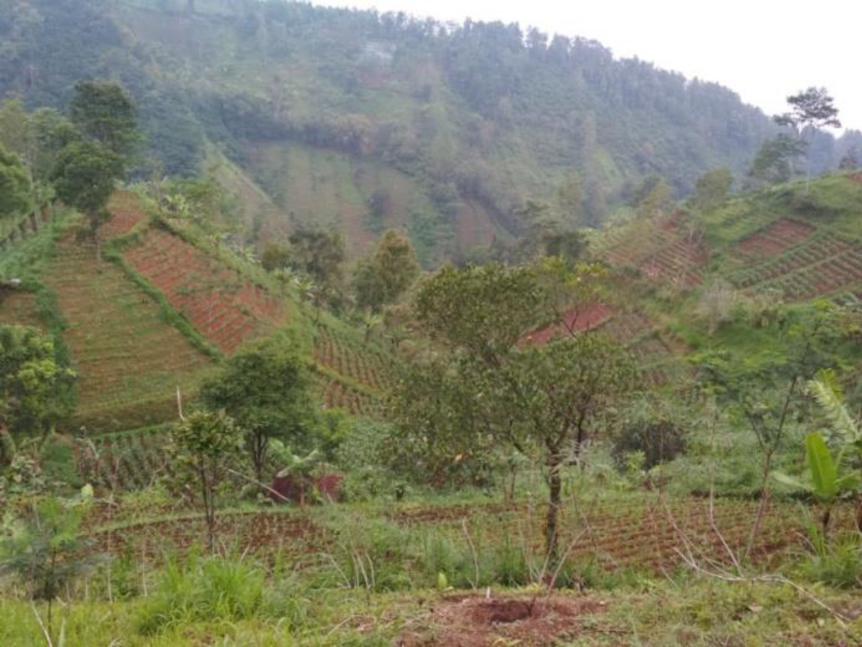

*Agriculture on slopes of the Naruan Micro Catchement area (Central Java, Indonesia)*

**Project title:** Development of participatory management of microcatchment in the Bengawan Solo Upper Watershed (Phase I) [Project ID: 2017P6-INA]

**Supervisory Agency:** Extension and Human Resources Development Agency, Ministry of Environment and Forestry, Indonesia (BP2SDM)

**Executing Agency:** Watershed Management Technology Center, Indonesia (WMTC)

**Budget in USD (total/APFNet grant):** 242,784/97,927

**Duration:** 6/2017 – 5/2019 (24 months)

**Project Category:** Demonstration Project

**Target economy:** Indonesia

**Goal:**

The project aims to develop participatory watershed management at a micro catchment scale by applying soil and water conservation principles. This model could be used as an example of successful watershed management in other micro catchments afterwards.

**Objectives:**

1. To improve the quality of the environment by increasing forest cover and the quantity and quality of water resources, as well as reducing the rate of erosion and sedimentation.

2. Increase farmers’ incomes through diversification of farm commodities, improve soil and water conservation technology and develop creative small businesses based on natural resources.

3. Build capacity and increase awareness in managing and conserving natural resources.

Outputs:

1. Increased stakeholders’ commitment for effective participatory management of micro catchment

2. Formulation of integrated participatory management of micro catchment

3. Establishment of demonstration plots of conservation farming and watershed rehabilitation

4. Enhanced community awareness in management of micro catchment

5. Monitoring & Evaluation (M & E) of watershed performance within scale of micro catchment, landscapes and household

**Activities**

**Activities 3.1 and 3.2:** Focus Group Discussion (FGD), coordination and dissemination with stakeholders

**Activities 4.1 and 4.2**: Technical plan preparation of micro catchment management, including the design of land rehabilitation and conservation of soil and water, planning of institutional empowerment and reinforcement techniques as well as inter-sector coordination

**Activities 5.1-5.3:** Implementation of micro catchment management, including the development of conservation farming demonstration plots (incentive), forest and land rehabilitation activities, applications of soil and water conservation measures, community empowerment and dynamics of farmer groups

**Activities 7.1-7.3:** M&E on the performance of micro catchment

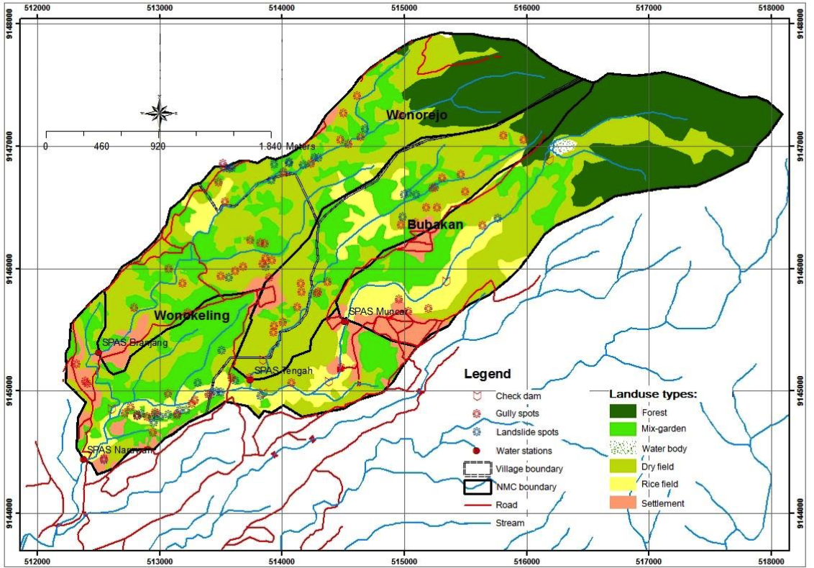

*Figure 1. Land use map of Naruan Micro Catchment*

**Project background**

Bengawan Solo River is the longest river in the Indonesian island of Java. However, the river’s Upper Bengawan Solo Basin is facing serious soil erosion problems, leading to increasing sedimentation flow into the Multipurpose Reservoir of Gajah Mungkur. The functions of the reservoir to control floods, supply water for downstream agriculture and hydroelectricity are now threatened, causing national concern. The Keduang Watershed is located in the Upper Bengawan Solo Basin and is one of the largest sources of sediment. The watershed is subdivided in several micro catchments, including, inter alia, the Naruan Micro Catchment which is the location of this project. Before the 1930s, this area was mainly covered by teak forests, however, large-scale deforestation and land clearing for agriculture occurred in the 1940s. In 2011, forest cover was only 2.25 %.

Reservoir sedimentation and forest degradation are very closely connected. Forests protect soil from the direct hit of rainfall and tree roots hold soil in place and increase the permeability of the soil to water, thus decreasing water and soil runoff. Therefore, the lack of forest cover increases soil erosion and causes an increased sediment flow into the reservoir. Intensive farming of annual crops on the highly erosive and steep-sloped uplands exacerbates erosion.

Watershed management requires an integrated and comprehensive approach. In 1974, a Master Development Plan for the Bengawan Solo watershed was created with little involvement of the community, and the upper stream is still facing severe soil erosion. Preliminary studies conducted in the Naruan microcatchment showed that more than 50 percent of the area has steep slopes and up to 33 percent is threatened by heavy erosion (>480 tonnes/ha/year). In this microcatchment, erosion is largely caused by agriculture. The development of a participatory management plan should involve not only the farmers but all stakeholders in planning and decision-making processes.

The APFNet project “Development of Participatory Management of Micro Catchment at The Bengawan Solo Upper Watershed (Phase II)” is located in the Naruan Micro Catchment (Fig.1), which is the upstream part of Keduang Watershed. The area of the Micro Catchment belongs to two different Regencies – Wonogiri and Karanganyar Regency – and is divided into three villages: Bubakan, Wonorejo and Wonokeling. The project aims to develop an operational participatory management plan for the Naruan microcatchment to tackle soil erosion. The executing agency in this project is the Indonesian Watershed Management Technology Center (WMTC) with the Indonesian Extension and Human resources Development Agency of the Ministry of Environment and Forestry (BP2SDM) as the supervisory agency.

**Project featured topics**

**Developing a participatory microcatchment management approach**

Top-down policy in watershed resources management often results in less effective and inefficient outcomes if they do not involve community stakeholders.

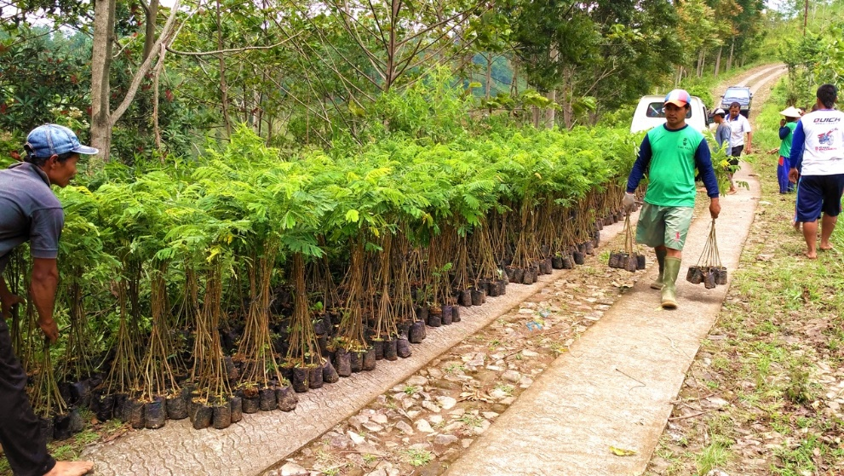

*Figure 2: Seedlings for restoration of the catchment*

An earlier preliminary participatory management plan had identified areas to be rehabilitated. The APFNet project organized focus group discussions to further identify and plan detailed actions to mitigate soil erosion, and increase collaboration and commitment of local stakeholders.

An integrated participatory management plan that included comprehensive implementation plans, and monitoring and evaluation of the watershed’s performance was developed. In total, around 100 households were selected, on a total demonstration area of 50 ha. A detailed land management plan and sustainable farming system – incorporating agroforestry and soil conservation practices – was developed for each household based on the specific land conditions (especially slope). The land management plan gave specific recommendations on planting patterns, species type (e.g. trees, crops, fruits and understory planting species) and landscape structures (e.g. terraces, drainage systems, gully structures). These plans were implemented and seedlings were distributed to the farmers (Fig.2). In the agroforestry planting designs, many perennial plants and trees were planted as an erosion control (Fig. 3).

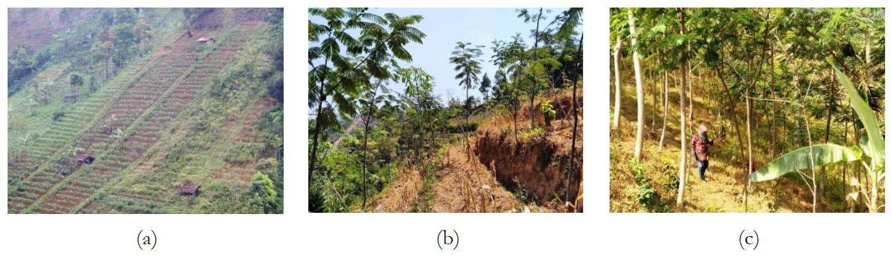

Figure 3: The conditions of agroforestry land (a) initial condition; (b,c) 1.5 years after

Successful microcatchment management can become a good model and prototype for managing large scale catchments for use by the Institute of Watershed Controlling and Protection Forest, and other institutions associated with watershed management.

**Finding the most profitable socioeconomic solutions with integrated and sustainable farming systems**

The project area included the Karanganyar and Wonogiri districts in Naruan microcatchment and both districts are national priority areas for rural development. The project encouraged local households to practice conservation agriculture and agroforestry to mitigate soil erosion and improve livelihoods. Conservation agriculture practices include minimal soil disturbance, year-round land cover and crop rotations. These practices can improve water-use efficiency, reduce soil erosion and increase crop production. In addition, agroforestry practices reduce soil erosion by combining seasonal crops with perennial trees, planted throughout the field with appropriate spacing. By selecting trees and crops species that can provide both short- and long- term benefits, incomes are increased over the long term and, at the same time, soil erosion is reduced.

**Project outcomes**

The M&E activities have assessed the impacts of the project through assessing both the physical parameters of the micro catchment and the economic situation of the households. Measurements of the discharge and runoff as well as the rainfall throughout different seasons did not display a direct impact of the building of technical civil structure to control small gully erosion or soil conservation agriculture at the slopes. However, this can be explained by limited scale of the project measures, e.g. approximately 50 ha of demonstration plots, compared to the size of the microcatchment, i.e. about 1000 ha. With regarding to predicting the soil erosion rate, it is expected that the impact of a constant soil cover in the plots through a design of timber and fruit trees combined with seasonal crops will reduce the soil erodibility in the long term, with benefits to be expected by 2023. Soil organic matter values, however, have already shown significant increases, from 3.07% to 4.03%. The dependence on annual crops, cattle and remittance from family members of the local population has decreased over the project phase. At the same time income from trading and timber has increased which is related to a more labor migration to the cities. However, often when migrating to the cities, the fields in the villages were planted with trees as an additional income source and erosion control.

APFNet-funded land rehabilitation in the Naruan Micro Watershed for Phase I increased farmers' income by an average of Rp. 1,318,486/ha/year. This increase in yield was achieved through the use of agroforestry, specifically a combination of woody plants (albizia) and seasonal crops (corn and cassava).

Even though community participation e.g. during the FGD and trainings on sustainable land use was good, the project team encountered some difficulties during the implementation of the participatory management plans. This was mainly related to scepticism towards planting perennial trees as farmers depend on income of seasonal crops and are hesitant to wait several years for the harvest of timber trees and partly also due to the land tenure system as many farmers are not land owners. These findings are going to be considered and addressed in the implementation and design of participatory management plans during the next project phase.